AI-Powered Real-Time Detection and Analysis of Marine Plastic Pollution


Project Team
Ubaid Ullah
B22F0263AI039
Muhammad Ahmad
B22F0700AI021
Azeem Tanoli
B22F1339AI010

Final Year Project
Supervised by
Dr. Jamil Ahmed
School of Computing Sciences
Pak-Austria Fachhochschule: Institute of Applied Sciences & Technology
Fall 2025
Chapter 2: Software Requirements Specification (SRS)
2.1 List of Features
The proposed system integrates artificial intelligence, remote sensing, and geospatial analytics to monitor and analyze marine plastic pollution in real time. Key features include:
1. Image Acquisition and Integration
- Supports ingestion of imagery from satellites (Sentinel-1/2, Landsat), drones, and shore-based cameras.
- Batch upload and automated scheduling (up to 100 images per session).
- Automatic metadata extraction (GPS coordinates, timestamp, sensor type).
- Validates formats (JPEG, PNG, TIFF) and resolutions (≥640×640 px, ≤50 MB).
2. Real-Time Video Stream Processing
- Accepts live streams through RTMP/HTTP/RTSP protocols.
- Performs real-time frame extraction (30 FPS default) with asynchronous buffering.
- YOLOv12-based detection at ≥15 FPS for active streams.
- Multi-stream support (3–5 simultaneous feeds) with WebSocket-based dashboard updates.
3. AI-Based Plastic Debris Detection
- Uses YOLOv12 deep learning model for classification and localization of marine plastics.
- Detects and classify 7 categories: PET bottles, HDPE containers, plastic bags/films, foam, fishing gear, mixed plastics, unclassified debris.
- Bounding boxes generated with confidence scores (0–100%) and normalized coordinates.
- Target detection accuracy ≥85% mAP on benchmark datasets.
4. Real-Time Analytics and Density Mapping
- Calculates pollution density (objects/km²) dynamically.
- DBSCAN clustering applies for hotspot identification.
- Provides interactive visualizations—heatmaps, geospatial overlays, and time-lapse pollution tracking.
5. Historical Data & Trend Analysis
- Maintains a comprehensive archive indexed by region, date, and plastic type.
- Offers comparative analytics, anomaly detection, and export tools (CSV, JSON, GeoJSON).
- Supports advanced filtering by time range, region, and debris type.
6. Automated Alerting & Reporting
- Configurable alerts based on defined pollution thresholds or hotspot emergence.
- Multi-channel notifications: in-app, email, and optional SMS.
- Automated and scheduled report generation (PDF, CSV, GeoJSON).
- Complete alert audit trail and acknowledgment logging.
7. Web-Based User Interface
- Secure, responsive dashboard for Admins, Analysts, Scientists, and Viewers.
- Interactive map and video visualization with detection overlays.
- Supports data filtering, historical exploration, and user management.
- Role-based access control with full activity logging.
8. API and Integration Layer
- RESTful APIs with JWT-based authentication and rate limiting (1000 requests/hour).
- OpenAPI/Swagger documentation for external integration.
- Enable collaboration with research institutions and government monitoring systems.
9. Security and Compliance Framework
- End-to-end encryption (AES-256 for data at rest, TLS 1.2+ for transit).
- Role-Based Access Control (RBAC) and bcrypt password hashing.
- Comprehensive activity audit trails.
- Compliance with GDPR and environmental data handling standards.
2.2 Functional Requirements
FR1. Image Source Integration:
- The system accept images from satellite APIs (Sentinel-1/2, Landsat), drone uploads, and fixed-position camera feeds.
- Metadata including GPS coordinates, timestamp, and device type shall be automatically extracted and stored for each image.
- The system shall validate image format (JPEG, PNG, TIFF), resolution (≥640×640 pixels), and file size (≤50 MB).
FR2. Image Pre-Processing:
- The system shall resize images to 1024×1024 pixels, normalize colors, and enhance contrast prior to detection.
- Invalid or corrupted images shall be rejected with descriptive error messages.
- Pre-processing shall complete within 2 seconds per image on specified hardware.
FR3. Real-Time Video Stream Processing:
- The system shall ingest live video feeds via RTMP, HTTP, or RTSP protocols.
- Frames shall be extracted at a default rate of 30 FPS and buffered for asynchronous processing.
- The system shall process at least 3–5 concurrent streams while maintaining a minimum detection rate of 15 FPS.
FR4. AI-Based Plastic Debris Detection:
- The detection engine shall use the YOLOv12 deep learning model to identify floating marine plastics with ≥85 % mean Average Precision (mAP).
- Detected debris shall be classified into seven categories: PET bottles, HDPE containers, plastic bags/films, polyethylene foam, fishing nets/gear, mixed aggregates, and unclassified plastics.
- Each detection shall include bounding boxes and confidence scores (0–100 %).
FR5. Geospatial Analytics and Density Mapping:
- The system shall convert pixel coordinates into geographic coordinates using image metadata.
- It shall calculate pollution density (objects per km²) and identify hotspots using the DBSCAN spatial clustering algorithm.
- Results shall be displayed through interactive maps and heatmap visualizations.
FR6. Historical Data Management:
- All detections and related metadata shall be archived and indexed by region, date, and plastic type.
- The system shall support search and retrieval by filters such as time range, region, and debris category.
- Historical data shall be stored for a minimum of two years.
FR7. Trend Analysis and Visualization:
- The system shall generate time-series graphs and comparative analytics showing spatial and temporal pollution trends.
- Users shall be able to export analysis results in CSV, JSON, or GeoJSON formats.
FR8. Alerting and Notification System:
- The system shall trigger alerts automatically when detection density exceeds predefined thresholds.
- Notifications shall be sent via in-app alerts, email, and optional SMS channels.
- All alerts shall include timestamp, geographic region, and severity level (low/medium/high/critical).
FR9. Automated Reporting:
- The system shall generate periodic and on-demand reports summarizing detections, density maps, and pollution trends.
- Reports shall be exportable in PDF, CSV, and GeoJSON formats.
- Report generation shall be completed within 30 seconds for multi-region analyses.
FR10. RESTful API Integration:
- The system shall expose RESTful API endpoints for authentication, image upload, detections, and analytics queries.
- APIs shall use JWT token-based authentication with rate limiting (1 000 requests/hour per user).
- API documentation shall be auto generated via OpenAPI/Swagger.
2.3 Non-Functional Requirements
NFR1. Performance:
- The system shall process a 1920×1080 image in ≤10 seconds on an NVIDIA RTX 3080 GPU or equivalent.
- Real-time video inference shall sustain ≥15 FPS.
- Web dashboard responses shall occur within 3 seconds under ≤50 concurrent users.
NFR2. Reliability:
- The system shall maintain ≥99 % uptime excluding scheduled maintenance.
- Daily backups with 30-day retention shall be automated.
- The detection model shall sustain ≥85 % mAP with false positives ≤15 % and false negatives ≤10 %.
NFR3. Scalability:
- Architecture shall support up to 1 million images, 10 million detections, and 500 concurrent users through horizontal scaling.
- GPU instances should be added dynamically without major architectural redesign.
NFR4. Security:
- Data at rest shall be encrypted with AES-256 and data in transit with TLS 1.2 or higher.
- Passwords shall be hashed with bcrypt (≥12 rounds).
- The system shall lock accounts after five failed logins within 15 minutes and log all security events.
NFR5. Usability:
- The interface shall be responsive and intuitive across desktops, tablets, and mobiles (320 px–2560 px).
- The UI shall comply with WCAG 2.1 Level AA accessibility standards.
- New users shall perform core tasks within 15 minutes without formal training.
NFR6. Maintainability:
- The codebase shall follow PEP-8 and maintain cyclomatic complexity < 10.
- Automated test coverage shall reach ≥80 %.
- Up-to-date developer, admin, and user documentation shall be maintained.
NFR7. Portability:
- The system shall be containerized using Docker and deployable on Linux (Ubuntu 20.04+), Windows Server 2019+, and major clouds (AWS, Azure, GCP).
- The database layer shall switch between PostgreSQL and MongoDB via configuration changes only.
NFR8. Compliance:
- The system shall comply with GDPR and environmental data-sharing regulations.
- Users shall have the right to request deletion of personal or location-linked data.
2.4 Use Cases
Use Case 1 – Upload and Process Image:
Actors: The User this could be a student Environmental Scientist, Marine Analyst
Flow:
- User uploads image(s).
- System validates and extracts metadata.
- Preprocessing standardizes image.
- YOLOv12 detects plastics and stores results.
- Annotated image displayed with bounding boxes.
Success: Image processed; detections archived and visualized.
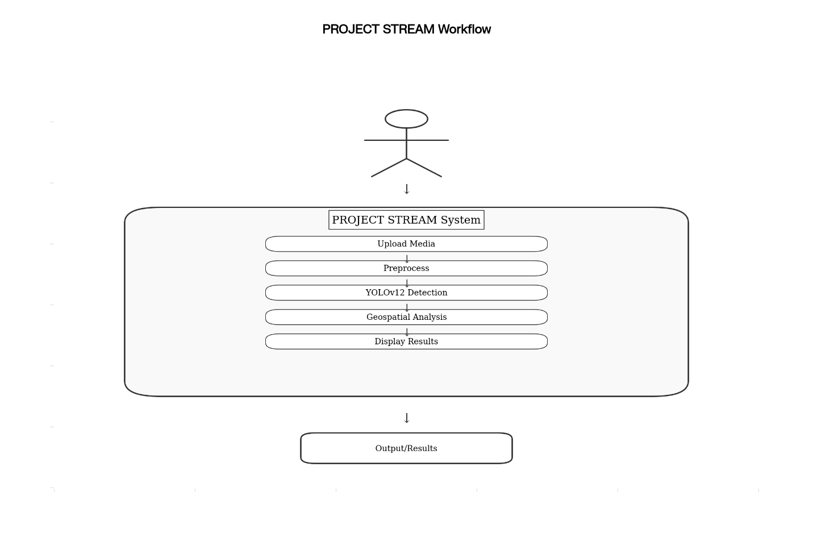
Use Case 2 – Monitor Real-Time Video Streams
Actors: The User this could be a student Analyst, Scientist
Flow:
- User selects live stream
- System processes frame in real-time
- Detections visualized on dashboard with overlays.
Success: Live detection active, dashboard updated continuously.
Use Case 3 – Analyze Regional Trends
Actors: The User this could be a student Analyst, Policy Maker
Flow:
- User selects region and timeframe
- System computes density and anomaly trends
- Generates comparative graphs.
Success: Time-series and hotspot visualizations produced and exportable.
Use Case 4 – Generate Reports
Actors: The User this could be a student Analyst, Scientist
Flow:
- User configures report
- Selects metrics and format
- Report generated (PDF/CSV/GeoJSON).
Success: Downloadable report created within 30 seconds.
Use Case 5 – Configure Alerts
Actors: The User this could be a student, Senior Analyst
Flow:
- User sets density thresholds, region, severity, and channels
- System monitors in real-time
- Notifications sent on trigger.
Success: Alert activated.
2.5 Software Development Plan
Methodology: Agile Scrum (2-week sprints, daily stand-ups, biweekly reviews).
Duration: 24 weeks (6 months).
Phase | Timeline (Weeks) | Key Deliverables / Milestones
M1 – Setup & Requirements | 1–2 | Requirement finalization, environment setup (Docker, GitHub CI/CD), YOLOv12 baseline validation.
M2 – Image Pipeline | 3–6 | Image ingestion APIs, metadata extraction, preprocessing, and database schema implementation.
M3 – Video Processing | 7–9 | Real-time video stream handling, multi-stream support, WebSocket dashboard updates.
M4 – Analytics & Reporting | 10–12 | Geospatial density mapping, clustering, reporting engine, export tools.
M5 – Frontend Development | 13–16 | Responsive UI, dashboards, role-based views, interactive maps.
M6 – Alerts & Security | 17–18 | Alert rules, notifications, RBAC, API authentication, encryption.
M7 – Testing & Optimization | 19–21 | End-to-end testing, load testing, model accuracy validation (≥85% mAP).
M8 – Deployment & Documentation | 22–24 | Production deployment, complete documentation, stakeholder validation.

Team Roles:
- Lead Developer: Model training and integration (Ubaid Ullah).
- UI/Testing Specialist: Interface and evaluation (Muhammad Azeem Tanoli).
- Data/Analysis Expert: Datasets and predictions (Muhammad Ahmad).

